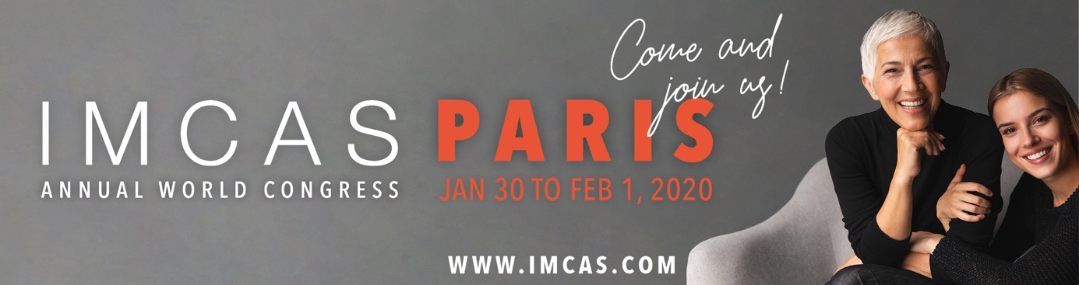

CALLING ALL MEMBERS!
IMCAS Annual World Congress 2020 Edition

Following the huge success of its 21st edition, IMCAS returns home to Paris to host the 22nd edition of the Annual World Congress from January 30 to February 1, 2020 at the Palais des Congrès.

The highly anticipated annual congress already has 11,000 expected attendees and 280 exhibitors, with over 800 international speakers leading 265 scientific sessions in 14 rooms.
One of the highlights of this year’s IMCAS World Congress 2020 scientific program is the Genital Treatments module. Led by world-renowned physicians in the field, this module explores the surgical and non-surgical procedures and the implications of emerging research on genital treatments. This extensive module is designed for both male and female treatments, with sessions dedicated to urinary incontinence, menopause, penoplasty, post birth laxity and complications. Check out the program for more details!
IMCAS Annual World Congress 2020 amounts to be the ultimate not-to-be-missed educational conference. Register now and benefit from the early bird rate before November 29, 2019. For a hassle-free congress preparation, get the “All-Inclusive” Badge and benefit from special hotel reservation rates. It’s badge and hotel in one easy package.

We look forward to welcoming you in Paris!

